Assignment 1

Q1. Write a program using loops.

Ans.

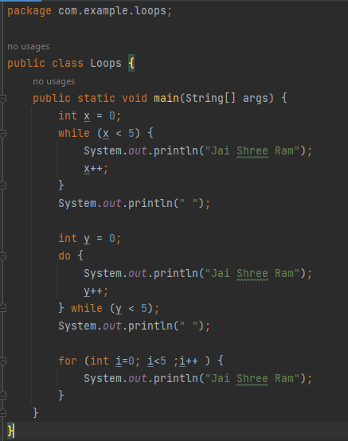

Output:

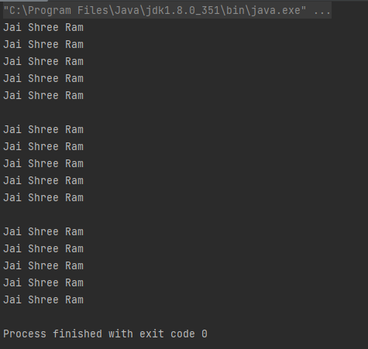

Q2. Write the program just like the previous question using recursion.

Ans.

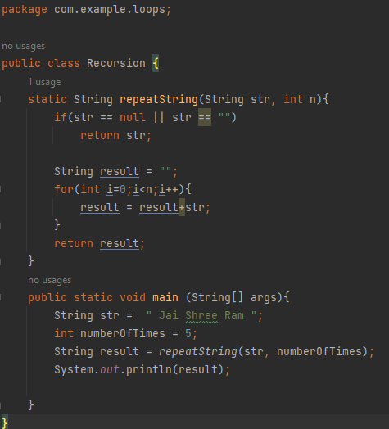

Output:

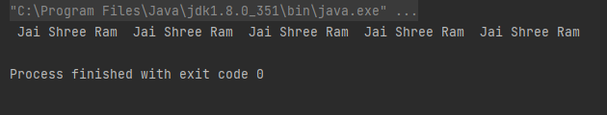

Comment on the analysis of both methods; which one is better and why?

Loop is better because in the recursion stack memory is used and it is not used in the loop. Recursion takes so much time and space complexity. Still, recursion is preferred because recursion is easier than a loop.